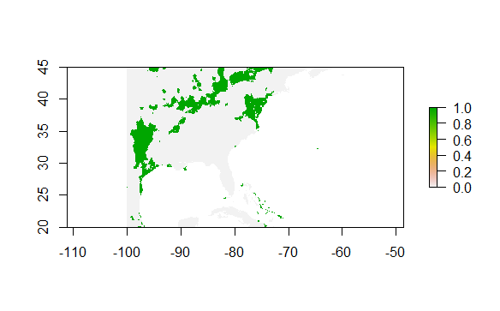

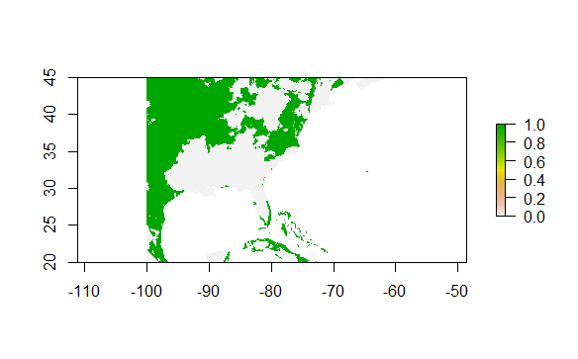

The top map is the current distribution of mallards and the bottom is the predicted future plot based on climate data. In the future extrapolation, it shows that there is a much larger distribution of mallards across this region. Places where mallards are not currently are predicted to have a large population in the future, especially towards the north. Some of the factors that control the population of mallards in the northern areas of this region could be related to climate. A possible explanation for this is climate change and the fact that the planet is getting warmer. With a warmer climate in the north, these habitats may become more hospitable to mallards than they are now. Because of climate change, the climate in the north could be similar in 2070 to the places that mallards are located now. In both maps, there are no mallards in the central area of this region above Florida. The factors controlling the population of mallards in this region are unchanged by the change in climate between the present and the future model.

Because there is a much larger distribution of mallards in the future, this shows that they could become overpopulated. A possible reason for this could be the death of their predators, which could be caused by humans or climate change. An overpopulation of mallards could affect the distribution of other animals as well. The bugs and plants that mallards eat could have a smaller population distribution in the areas where mallards are because many of them are looking for food.